Notes for MiTaL discussion

From Megan, 3/25/25

* Library labels: please include more labels! I was struggling to find questions and to pick a label for them. This ties in with a statement about organization – with longer sections comes an increased challenge of navigating (primarily for students). I personally would prefer a greater number of shorter sections if it meant greater clarity in knowing where to go. Can we do sub-libraries? Like have a “geometry” label, but within it put “area”, “volume”, “similar shapes”, and so on?
* The short videos you sent: they are professional level. Lovely! I already gave you my critiques.
* Solving formulas. *Please* keep them in 3.1. That way solving linear equations is kept together (vs in 1.3, which is more about crafting linear equations).
* Response to this: (which I forgot to respond to earlier) When including units in calculations which I am doing where there are mixed units for multiple reasons (shared previously), what is the optimal way to typeset them. See below for examples meant to clarify the  
  question.  
    
  150 g * 0.22 = 33 g  
  vs  
  (150 g)*0.22 = 33 g  
    
  2nd example  
    
  9.8 ft/s^2 * 10 s = 98 ft/s  
  (9.8 ft/s^2) (10 s) = 98 ft/s – Response: in both cases I like the first way more, but am perfectly content to live with whichever way you decided.
* 3.5 comments:
  + When solving, I notice you combine like terms until you have a proportion, and then invert the proportion as necessary, to finally solve by multiplying. I teach this with clearing fractions. Is there a reason you approach it this way?
  + Rounding in example 3.5.15… that is a VERY subjective rounding rule! I would have rounded using normal rounding rules.
  + Exercise 2: graph doesn’t completely show.
  + Exercise 3: missing 2nd answer box.
  + Exercise 4… my students struggle with “… by a factor of___.” Those who know more algebra can process it, others can’t. This isn’t something that I explicitly teach (maybe I should change). Does the book cover it?
  + Exercise 10: Do you think we need to specify that the different hoses are attached to different water sources? Or is that implied?
  + #11-14… I have these in my homework for this section because they are inverse variation problems… but I’m not sure they belong here. Aren’t they better suited to be in the section on variation (3.4)? What do others think?
  + Please have more than one “solve the formula” question!
* 3.6 comments:
  + For #11, just for the record, some of my students fail to make the connection that the break-even point is when cost = revenue.
  + #14 requires realization that distance = rate*time. I’m inclined to believe that not all of our students come in knowing this. The modification of the speed also seem to be a challenge.
  + Contrived questions are an issue here. I have no suggestions how to fix that. We may be stuck with them.
  + One of my struggles in this section is to help my students figure out how to construct the equations (as in what the equation will be about). I approach this by asking two questions: (1) what are we trying to find? Those are our variables. (2) what kinds of things is the question about (as in $, lbs, L)? Those are what our equation is about. This seems to help students mentally organize what they are looking for.
  + More mixture problems, please! Maybe Question ID 296430 or Question ID 152972.
* 4.1 comments:
  + In the section itself, you have the Pythagorean Theorem just listed there, with no introduction. I see that what people struggle with is when to use which tool – saying something about side length (vs area) may be a useful introduction.
  + Maybe add a question like this:

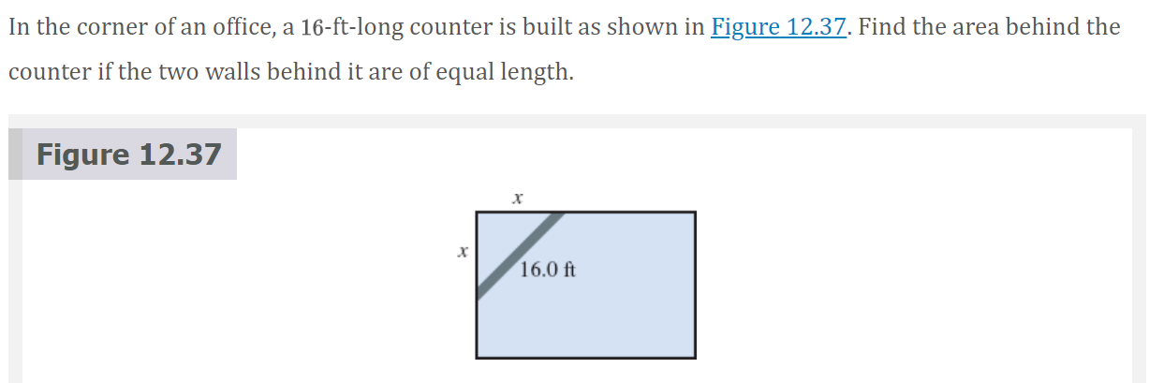

* + 
  + In Example 4.1.30, please delineate that the 6 in 168 is the last significant digit.
  + Exercise 8: I skimmed, but I don’t think triangles that do not exist were covered in the section.
  + Exercise 13: not covered in section.
  + #18 is clunky. Could we make it not multiple choice? And include units? And don’t ask rhetorical questions unless you want students to answer them.
  + #23 doesn’t need to be changed, but it is so clearly not your voice. I thought that was funny.
  + I don’t understand Exercise #24. “As the rounded rectangle area is increased, what is the area it will never exceed?” As the area increases, it can get as large as one desires. Do you mean as the radius changes?
* 4.2 comments: Lucky you, I did not get to this section. Hah!
* Comments from my students about MiTaL, take it or leave it Mark!
  + One person wanted to know more of *why*.
  + Another felt that the book was really good for the introductory ideas, but didn’t go far enough to explain the more challenging/confusing pieces.